**April 2013 v1**

**4Screen**

LEGAL NOTICE

*ASU30*

*ASU30 and ATUU30 are acronyms for Adult Smoker Under 30 and Adult Tobacco User Under 30. The term ‘adult’ is defined by local law, but shall in no circumstance refer to any person under the age of 18. Likewise, consistent with BAT’s International Marketing Standards, terms such as ‘consumer’, ‘target consumer’, ‘smoker’, or ‘target audience’ refer only to smokers whom are adults.*

LOCAL LEGISLATION / REGULATIONS

*The material contained in this document may present executions and themes that are not legally permissible or acceptable in some markets. Likewise, because tobacco regulation and the company’s own views on socially responsible marketing change over time, previously approved activities may no longer be permissible. Therefore, you must obtain local legal and CORA approval before proceeding with any activity in your market.*

*COPYRIGHT AND CONFIDENTIALITY*

*© British-American Tobacco (Holdings) Limited 2013. All rights reserved. No part of this document may be reproduced in any form or any means without the prior written consent of British-American Tobacco (Holdings) Limited (˝BAT˝).*

*This document is proprietary to BAT and is provided to employees of the BAT Group and certain trusted contractors working for a member of the BAT Group. It is disclosed solely for use by employees in the course of their employment or by contractors for the purpose of facilitating the provision of services by that contractor to the employing BAT company and for no other purposes. Unauthorised possession or use of this material or disclosure of the proprietary information without the prior written consent of BAT may result in legal action.*

*THIRD PARTY TRADEMARKS*

*“Trademarks, logo designs and/or brand names featured in this material and not owned by British American Tobacco PLC (or one of its group companies) are owned by the relevant proprietor of the particular trademark and/or brand name in question, and are referred to in this document for informational and/or illustrative purposes only.”*

Table of Contents

1. Overview – 4Screen Study: 3

2. How to set up a 4Screen study? 5

2.1 Design considerations 5

2.2 Sample Size and type 6

2.3 Target Group 7

2.4 Stimulus materials and requirements 7

2.5 Interview location and requirements: 9

3. The Interview and Questionnaire 10

3.1 Interview Flow: 10

Illustration of questionnaire flow based on 4 concepts: 11

3.2 Questionnaire flow and information areas: 12

4. Key Metrics and Analytics 13

4.1 Action Standard Setting: 13

4.2 Key Deliverables: 14

4.2.1 How are the ideas/concepts prioritised? 14

4.2.2 Is the idea/concept good enough to progress to the next stage of the innovation process? 15

4.2.3 How can the idea/concept be refined? (OPTIONAL) 16

5. Agency for 4Screen 17

# Overview – 4Screen Study:

4Screen is the first part of the BAT 4Suite Innovation Testing toolkit. The tool has been designed to screen and prioritise early stage ideas and concepts to help decide which ones are worth taking forward to the concept development stage.

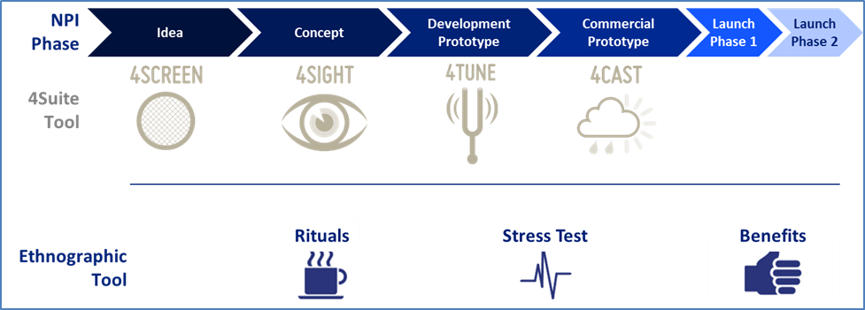

4Screen can be used to test either early stage ideas or concepts – the type of test will need to be decided in advance:

* **Early stage ideas** – Unbranded and “un-priced” ideas that include an insight, benefit (claim) and a product description.
* **Early stage concepts** – Branded concepts. In addition to an insight, benefit (claim) and product description they include a reason to believe, a tagline, a price and an image or illustration of the concept.

The key business question that 4Screen helps to answer:

* ***What are the most promising early stage innovation ideas or concepts i.e. whether the idea/concept is good enough to justify taking it forward to the next stage of the innovation process?***

4Screen uses standardised metrics to determine whether an early stage idea or concept should be dropped, de-prioritised, refined or progressed to the next innovation stage. 4Screen is a **screening tool** that will provide key metrics and diagnostics but no volumetric projection. The focus is on screening/ranking and comparing against a normative database. 4Screen is not suitable for testing more developed concepts or offers.

4Screen has also a range of indicators embedded that will help to understand the appeal and potential main issues with early stage ideas/concepts.

When testing new ideas/ concepts it is important to understand how they perform compared to other ideas/ concepts BAT has tested earlier and to other products in the market that consumers are interested in. 4Screen will eventually provide benchmarking to the BAT Tobacco Innovations database *(once we have built norms with 4Screen studies)* as well as the Kantar TNS ex-category innovations database. These benchmarks will help us to understand how the tested ideas/ concepts perform on the main indicators against other tobacco ideas/ concepts and ex-category innovations.

A 4Screen study takes about 8 weeks from the moment the stimulus materials are ready to test. Additional time needs to be reserved for the planning of the study and development of the stimulus materials.

4Screen is recommended for Cap3 innovations and optional for Cap2 innovations. The main focus of the methodology is in providing prioritisation (i.e. screening) of a larger number of early stage ideas or concepts and this stage may not be relevant for all projects.

Lead markets for the Cap3 and Cap2 innovations are decided and governed by the IPSG and Brand SGM’s. Typically 3-4 lead markets would be used for prioritising the ideas / concepts and making a decision on which ones to take forward.

Any 4Screen study requires always the sign-off from Global Oracle Manager.

# How to set up a 4Screen study?

4Screen is a quantitative test where each respondent tests several ideas/concepts in a Sequential Monadic manner during a single visit.

Due to logistical and confidentiality issues the recommended setup is a central location test where we have full control of the materials shown to the respondents.

CAPI (Computer Assisted Personal Interviewing) is preferable to non-electronic data collection methods due to the ability to fully automate the randomisation of concepts and to remove the risk of data entry errors.

## Design considerations

* Maximum of 6 early stage ideas or 5 branded concepts may be seen per respondent to maintain quality of responses and keep the interview length within reason.
* If a larger amount of ideas/concepts need to be tested then a matched panel setup is required including one common idea/concept to be used across all panels.
* Concepts are always fully rotated within the panels to overcome order bias.
* The basic requirement is that ideas/concepts are different from each other rather than slight modifications of the same idea/concept. It is important that they are sufficiently different in order to be each rated as a unique differentiated innovation. If among the ideas/concepts there are some which are rather similar we need to ensure in the setup that they are kept apart from each other (restricted).
* If the same concept is tested with multiple brands these need to be isolated in monadic panels.
* The necessity to separate/isolate ideas/concepts will be judged on case-to-case basis. Therefore it is very important to share all the ideas/concepts with research agency during briefing stage so that proper evaluation can be done and the research design planned accordingly.

Normalisation of the sequential dataset:

Ideas/Concepts that are tested in the sequential monadic set must always be normalised so that the response data becomes equivalent to monadic reading. This is a standard practice in idea/concept testing to account for order effect and it is also needed for the normative database benchmarking. Please note that in a normative database we always refer to monadic scores.

Normalisation is done by comparing the aggregate score of all of the concepts seen in the monadic position with the aggregate score of all of the concepts seen sequentially. Both of these totals are always robust even if the monadic base per concept may not be. The difference between the two scores is then used to calibrate the sequential ratings at the idea level so that the scores are monadic-equivalent. Each question is normalised separately because the impact of being presented sequentially may vary by question and by the type of idea/concept tested.

The research agency will handle the normalisation at the data processing stage.

## Sample Size and type

The sample size for the 4Screen depends on the number of ideas/concepts evaluated. The basic rule is that each option needs to be fully evaluated by at least 150 respondents. Therefore if we have only 2 or 3 ideas/concepts to evaluate the sample size is minimum 150.

If we have 4 ideas/concepts the sample size required is 200. For 5 options the sample size required is 250 and for 6 options 300. This sampling approach would ensure that we have minimum 50 sample size at monadic level for any given idea/ concept and the ratings at this monadic level would be utilised to normalise the overall scores.

If any subgroup analysis or boosts are needed, the minimum sample size of 150 should also be applied to these. The overall sample can be increased to achieve this minimum or, for particularly low incidence groups, it may be more suitable to use a boost to avoid the main sample becoming too large (which would impact cost, time and feasibility). This should be decided on a case-by-case basis.

If there are more than 6 ideas/ 5 concepts, then matched monadic panels need to set-up, again using the minimum 150 sample size criterion.

## Target Group

The objective of 4Screen is to use a set of target consumers to rank and prioritise the ideas/concepts. 4Screen does not require an all-market sample however if needed that can be done as well. It is also important to remember that in order to be able to properly compare the ideas/concepts in the future against previous studies (normative database) we need to keep the target group for a particular type of study as constant as possible. The recommended target groups are as follows:

* **Premium Innovations:** Smokers in Premium and Aspirational Premium segment
* **Value for Money Innovations:** Smokers in VFM segment
* **Low priced Innovations:** Smokers in Low segment

Once the target group has been selected we need to ensure that we have at least 80% coverage within that target group considering a good spread with geographic and demographic factors.

## Stimulus materials and requirements

4Screen requires a comprehensive idea/concept exposure to ensure respondents get a good idea of what the early stage idea/concept is and what the benefits are. Even though we are working with early stage ideas or concepts it is very important to put special emphasis on developing clear and effective stimuli for 4Screen to provide the best representation to respondents.

4Screen requires the following stimulus:

* **Ideas or Branded concept boards** – either printed or electronic (CAPI) for the early stage ideas or concepts that needs to be evaluated. For branded concepts, price should be clearly mentioned in the board. In order to avoid any undue bias, all ideas/ concepts going into any study should have the same treatment in terms of quality and finish (e.g. same background colour, same balance between text and pictures and same level of readiness). Important to remember that this is about evaluating the relevance and potential of the concept itself rather than the visual elements of the board.

It is very important to review the feasibility and the availability of the stimulus before starting to plan for the test and to right away discuss any stimulus material limitations with the research agency.

The amount, type and quality of stimuli have big potential implications on the study design, cost and timings. Concept stimuli should be provided during brief discussion stage so that proper evaluation of these can be done to determine fit with 4Screen methodology and any possible design implications. Also final ideas/concepts are needed to be incorporated into the flow of the interview and tested prior to the launch of fieldwork.

With the exception of refinement of ideas/concepts, it is essential that stimuli remain consistent across tests, e.g. if entering the same idea/concept into further rounds of 4Screen or progressing to later stages of 4Suite. This ensures comparability of understanding.

Stimuli for early stage ideas should be around 40 words long and comprise an insight, benefit (claim) and product description.

Stimuli for early stage concepts should be around 80 words long and comprise a brand name, insight, benefit (claim), product description, reason to believe, tagline and price.

## Interview location and requirements:

The recommendation for 4Screen is to do the interviews at central locations due to easier logistics and potential confidentiality issues.

Recruitment will be based on a set quota and will be then followed by the main interview.

The number of central locations required for the test varies per market and by the nature and type of target group. The number of central locations has an impact on the stimulus material requirement, cost and timing so it is important to discuss these options in advance with the research agency.

CAPI is the recommended data collection method to ensure correct rotation within the interviews especially when a number of different options are being tested. PAPI (Paper and Pen) is technically possible but should be only used if no other alternative exists. If PAPI is used, extra fieldwork controls need to be put in place to control the correct rotation.

The other aspect to consider is confidentiality and how that impacts the stimulus materials. 4Screen is designed to test early stage ideas/concepts that the company is likely to invest large sums of money into. At this stage, ensuring that the respondents do not take any stimulus materials home and/or that only the recruited respondents see the materials is essential.

If electronic stimulus is used it is very important that the coordinating agency reviews at an early stage what sort of computers the fieldwork agency has in use. If there is any risk of bad quality computer screens that may undermine the quality of the electronic stimuli we need to either revert to printed materials or alternatively discuss with the coordinating agency the feasibility of arranging computers for the fieldwork agency to use.

# The Interview and Questionnaire

4Screen is a one-visit test with pre-recruited consumers. Typically the consumers are first recruited by using various methods and quota sampling – after which the suitable consumers are invited to the central location interview.

The 4Screen interview takes about 25 minutes. The exact length depends on the number of modules included and the number of concepts being tested. The interview allows for up to 6 early stage ideas or 5 branded concepts to be tested. This limit is put in place not only to ensure a reasonable interview length but also to reduce exposure fatigue which can lead to poor quality responses. As the innovative ideas/concepts are all supposed to be different from each other there is a lot of information that the respondent needs to digest. Fundamental research has shown that if consumers are exposed to more then 5-6 concepts the quality of the responses and their ability to rank logically starts to deteriorate.

## Interview Flow:

4Screen follows a specific interview pattern which is not a pure sequential monadic.

First all of the core questions (shown below) are asked as a block for the first idea/concept.

Secondly we ask purchase intention for all of the remaining ideas/concepts before going through the other questions as a block for each of the remaining concepts in turn.

Core questions:

* + Purchase Intention
  + Value for money perception (branded concepts only)
  + Overall liking
  + Uniqueness
  + Relevance
  + Excitement
  + Clarity
  + Believability
  + Brand fit (branded concepts only)

## Illustration of questionnaire flow based on 4 concepts:

Purchase Intention is used to normalise scores in order to derive monadic equivalents which is essential for database construction. Therefore this question is asked upfront for all the ideas/ concepts in order to account for any order bias. Experimental work shows that after normalisation is applied this questionnaire flow provides a score for purchase intention that correlates more closely with scores achieved using a full monadic study.

## Questionnaire flow and information areas:

1. **Screener**

|  |  |
| --- | --- |
| **Section** | **Question** |
| **SCREENER** | Gender |
| Center |
| Age Screening (Exact Age) |
| Age Screening (2) |
| Trade / profession screening |
| Whether participated in market research |
| Whether participated in tobacco research |
| Smoke cigarettes daily |
| Average daily consumption |
| Regular brand |
| Time with regular brand |
| Demographic questions to be included as per market needs |
| Purchase frequency |
| Occasional brands |
| Occasions of smoking |
| Regular brand disposition |

1. **Main interview**

|  |  |
| --- | --- |
| **BRAND AWARENESS, USAGE & DISPOSITION** | Regular brand reconfirmation |
| Prompted awareness |
| Trial in last 3 months |
| **CORE MODULE** | Purchase intention |
| Overall Liking |
| Overall Liking 6 point scale for ex-category comparison |
| Uniqueness |
| Relevance |
| Excitement |
| Clarity |
| Believability |
| Price perception |
| Value for money perception – for ex-category benchmarking |
| Fit with House |
| Purchase intention for other concepts / ideas |
| **RANKING** | Ranking |
| **TALK VALUE** | Sources of information |
| Recommend ability |
| **FUTURE SHAPERS** | Future shapers questions (TO BE USED ONLY FOR PROFILING) |
| **OTHER ADDITIONAL QUESTIONS** | **IN CASE OF INCLUSION WILL BE INCLUDED AT RELEVANT POSITIONS BASED ON THE QUESTIONNAIRE FLOW** |

# Key Metrics and Analytics

## Action Standard Setting:

4Screen test works in a relative manner. Based on two key measures – *Purchase Intention* and *Uniqueness*, concepts will be mapped into the following analytical framework:

* **Unlikely to succeed:** Low trial and low uniqueness
* **Winning ‘me too’:** High trial but low uniqueness
* **Sustainable?:** High uniqueness but low trial
* **Novel winners:** High uniqueness and high trial

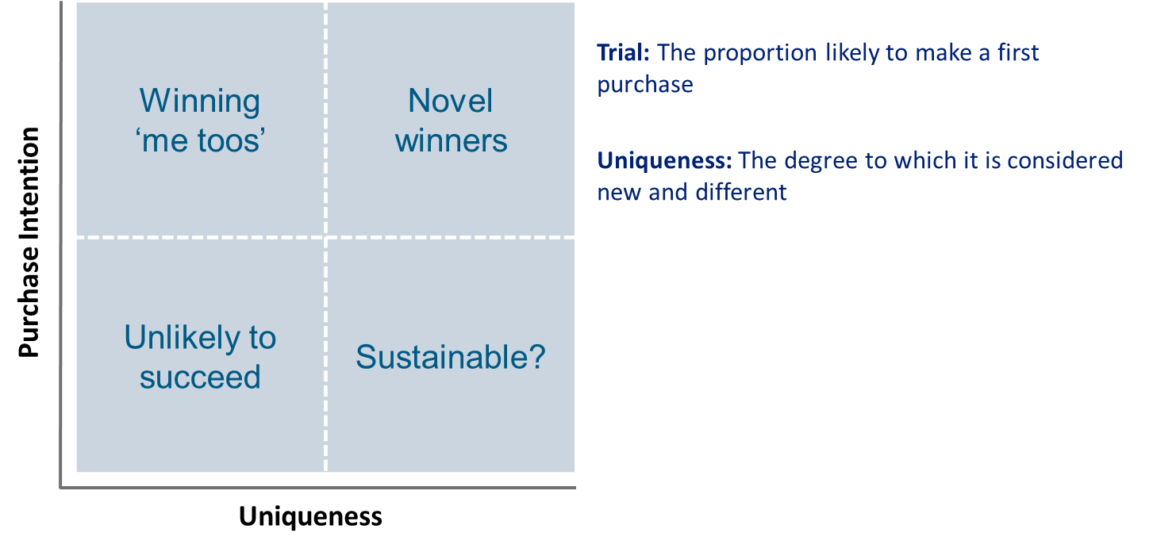

Using the above matrix (and additional analysis as detailed below), early stage ideas or concepts will be shortlisted and recommended for progressing to the next stage of innovation development.

## Key Deliverables:

A 4Screen tobacco database will be developed that will allow benchmarking of core metrics against previous ideas and concepts. However, until this is available and sufficiently populated it will only be possible to decide whether to progress ideas/concepts by judging if the scores achieved are acceptable at an absolute level and relative to the other ideas/concepts being tested at the same time.

The 4Screen analysis is divided into the following areas:

1. *How the ideas/concepts are be prioritised?*
2. *Is the idea/concept good enough to progress to the next stage of the innovation process?*
3. *How can the idea/concept be refined? (OPTIONAL)*

### How are the ideas/concepts prioritised?

4Screen provides a score for each idea/concept against each of the core metrics. This allows comparison between concepts and helps to determine which of the ideas/concepts have performed well and which have done less well (see example below). Once decided which, if any, to progress, these ratings can be used to prioritise development.

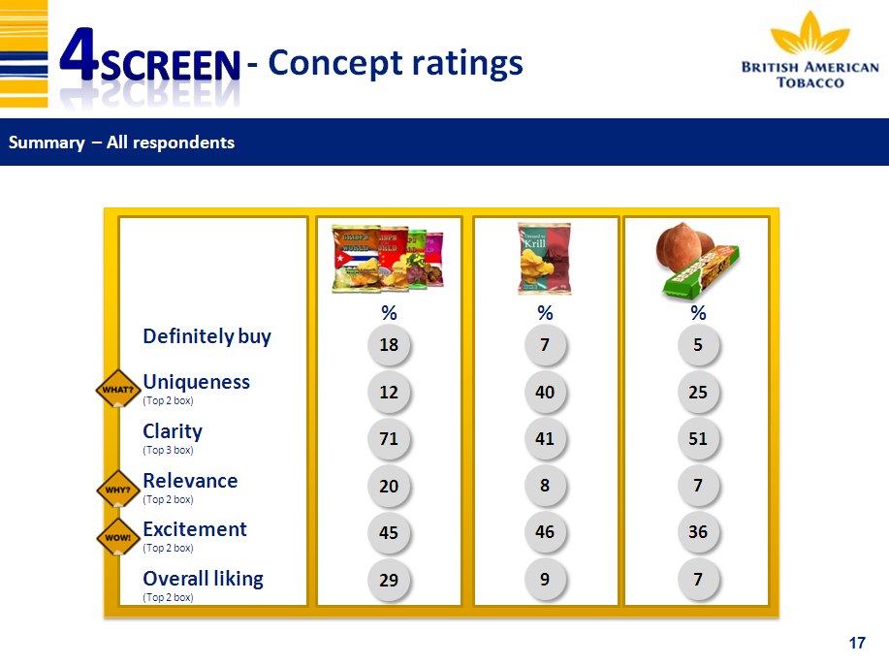

### Is the idea/concept good enough to progress to the next stage of the innovation process?

A one page summary (see example below) is provided for each idea/concept, showing the recommended action based upon the individual scores and benchmark to reference.

For referencing, the 4Screen normative database will be used in the future to provide a means of rating each concept against concepts that have previously been tested within the same target group. This would essentially show how the top rated idea fare relative to market standards for that target group. These benchmarking against norms would be available only when we have built a sizeable repertoire of 4Screen studies.

Therefore until the 4Screen normative database becomes available we will be including a reference idea/concept in all 4Screen studies. Ideally, this should be a concept that has not yet been launched but that has been previously tested and is well understood.

Different reference concepts may be used in different markets but within each market the concept used should remain the same. If a reference concept is unavailable it is also possible to use a recently launched product but it should have low prompted awareness (threshold to be determined on a case-by-case basis) and low market penetration. It is important that there is consensus within the BAT business about the classification of the reference concept as a success or a failure. If no such reference is available, the prioritisation (or screening) would be based only on absolute scores (i.e. whether the top rated idea is good in terms of market context cannot be measured).

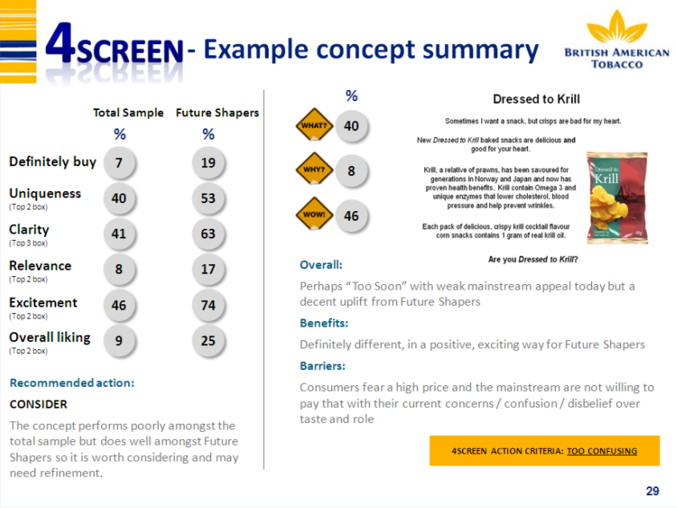

### How can the idea/concept be refined? *(OPTIONAL)*

Additional questions can be incorporated if needed to provide further diagnostic (e.g. open ended likes/ dislikes can be used to understand possible triggers and barriers, list of occasions to map possible alignment, preference as regular or occasional etc.). However given that it is a screening tool meant to screen a number of early stage ideas/ concepts, addition of any optional questions should be properly evaluated against respondent fatigue/ quality of response.

**Note about normative databases:**

A BAT proprietary normative database for 4Screen will be eventually built from the 4Screen studies that we will conduct. The database will be maintained and updated by IMRB International. As this is a new thing for BAT and in the beginning we do not have our own norms it is very important to discuss the availability of alternative benchmarks right at the outset of the study. Until the normative database becomes available we recommend including a reference idea/concept in all 4Screen studies (as detailed out earlier).

Any ex-category benchmarking (beyond the tobacco category) will be done by utilizing the Kantar TNS normative database. Depending on what type of innovation we are testing, the agency will propose a suitable benchmark from the database. The availability of normative data from the ex-category database must be reviewed in advance with the agency when planning a 4Screen study. Where normative data is not available it may be possible to use data from another category or market as a proxy. However, this should be decided on a case-by-case basis as it involves data calibration and is therefore a compromise solution. It should also be noted that in some cases the normative database may not represent a fair comparison for ideas/concepts being tested, e.g. if a breakthrough innovation is being compared against normative data that largely comprises line extensions. Again, this needs to be discussed on a case-by-case basis.

Please note that when using the ex-category databases we have to ask the benchmarking questions in the same way as they have been initially asked when capturing the norms. The research agency will discuss with BAT possible solutions to align questionnaire in the right way if ex-category benchmarking is needed.

# Agency for 4Screen

All 4Screen studies are coordinated by IMRB INTERNATIONAL. Fieldwork agency can be selected as per our normal process.

For the ex-category benchmarking, we use the Kantar TNS database and this service needs to be purchased from TNS at an additional cost. IMRB International will contact TNS to obtain a quote and will handle the interaction with TNS to get the relevant norms.